3) Create a windows vm using CLI.

Creating subnet

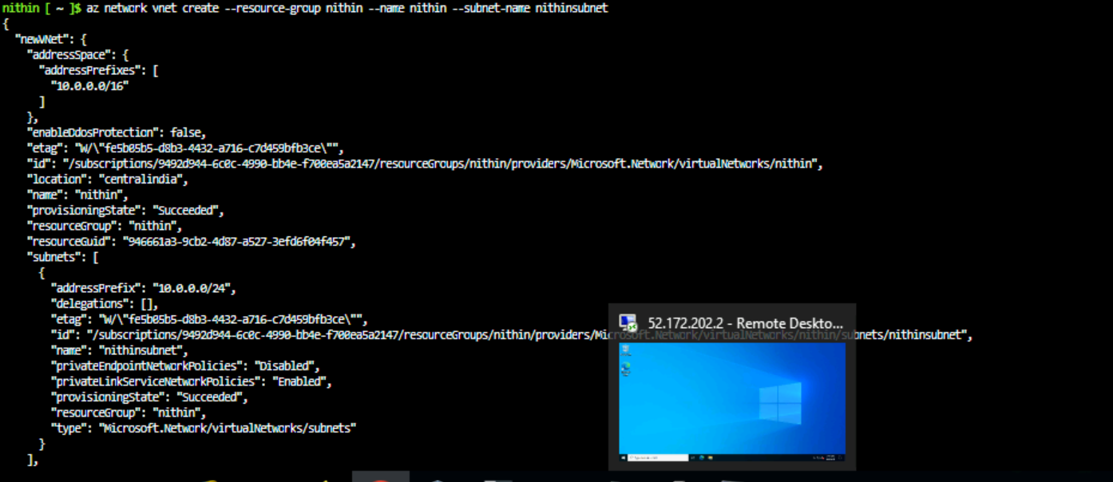

Creating Public IP for the VM

Creating the network security group

Creating the Nic card

VM creation

Opening the port for connecting the virtual machine

Overview of the VM created in the Azure

Created Virtual desktop Interface

4) Create a VM scale set for window OS where average CPU utilization is > 50 regarding that its should scale up and scale down.

i)First we have to create a VMSS to scale the VM based on the CPU load.

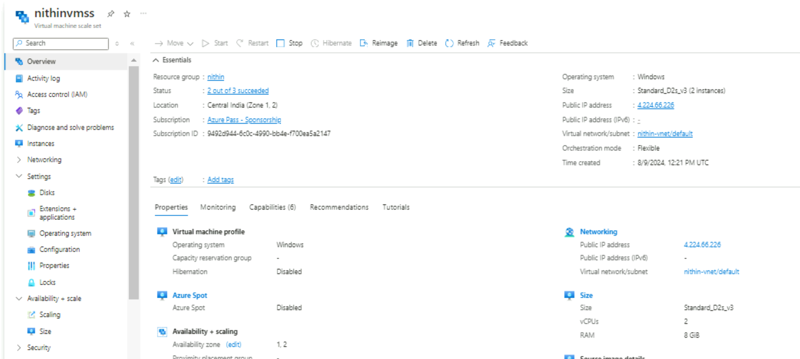

ii)we increased the load of CPU using an app.

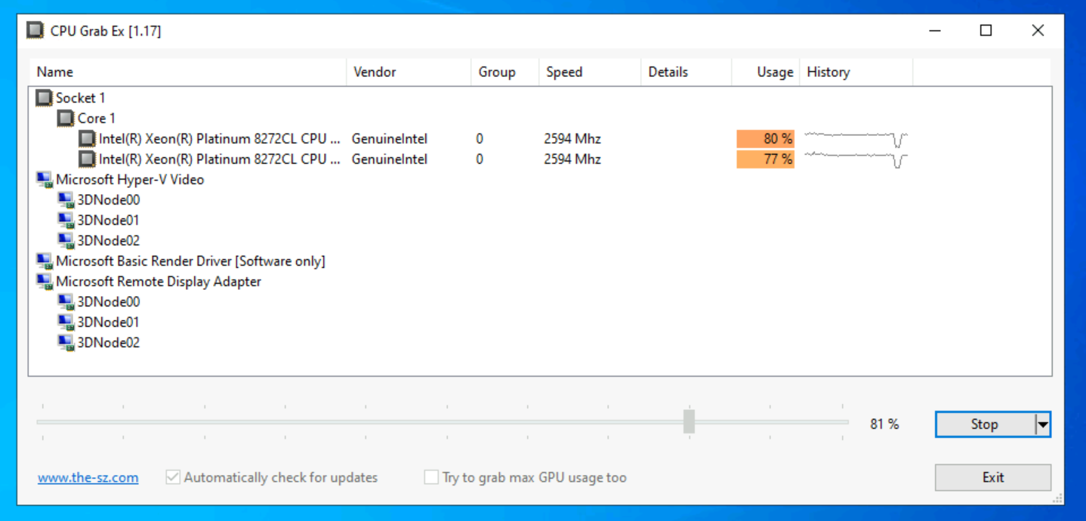

iii)Because the CPU load is more than 50% , so it is creating a instance to balance the load.

iv)creation of new instance is completed.

v)we reduce the load of the CPU to less than 50%, for checking the lower loads

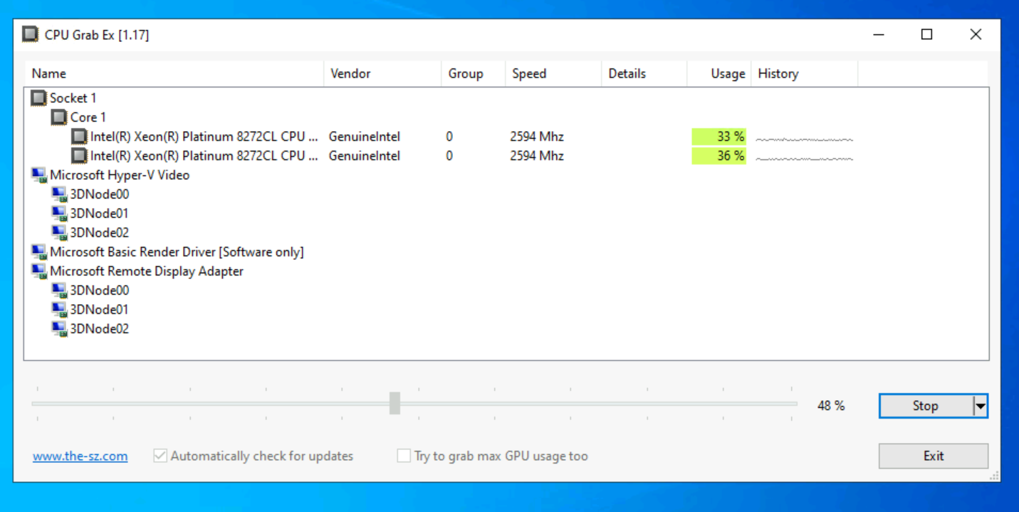

vi)It is creating the new instance for the reduced load.

vii)New Instance was created for the decreased load of CPU.

5) Deploy the spring pet clininc on azure app services.

i)Deploying the web app for the spring pet clinic with the name called Jayaapp.

ii)first we have to fork the respective spring pet clinic repository to our github repository and while deploying the web app we have to link our repository in web app deployment part.

iii)After that, we have to deploy the web app services and after the completion of deployment we have to check the actions in github to check whether the service is successfully deployed or not. A screenshot of a computer

iv)Click the browse option available in the Azure app services to check the web app launched successfully or not.

